**CTEC 305 Project 4 Report**

Rosemarie Kpaka

Bowie State University

CTEC 305 Server Administration 1

Professor Charles Wolford

November 14, 2024

**Introduction**

For this project, I implemented disaster recovery measures and designed an organizational structure within an Active Directory (AD) environment to improve operational continuity and user management. Using a simulated infrastructure of VMware virtual machines (VMs), I configured backups, established organizational units (OUs), created security groups and users, tested the Active Directory Recycle Bin, and managed Flexible Single Master Operation (FSMO) roles to enhance the domain’s resilience and functionality.

**Environment Setup**

* VM Count: Six virtual machines (VMs).
* Domain Controllers: Two VMs designated as RKDC01 (primary) and RKDC02 (secondary).
* Backup Server: One VM running Hyper-V, named BackupSVR-01.
* Member PCs: Four VMs (RKPC1 to RKPC4).
* Software Used: Windows Server 2022.

**Configuration Steps**

**Step 1: Create a Disaster Recovery Solution**

1. Set up a Backup Server:

* Created BackupSVR-01 with Hyper-V installed.
* Added a new virtual hard disk labeled Backups.

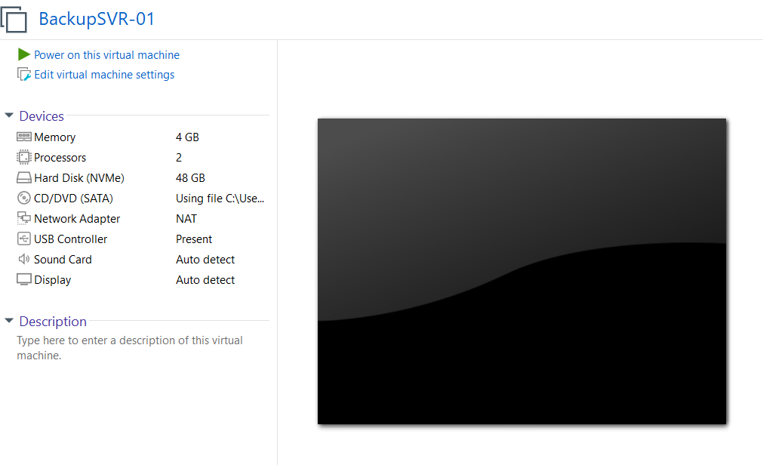

1. Partition and Configure the Backup Disk:

* Initialized and formatted the Backups disk with NTFS.
* Created two folders: DC01 and DC02.

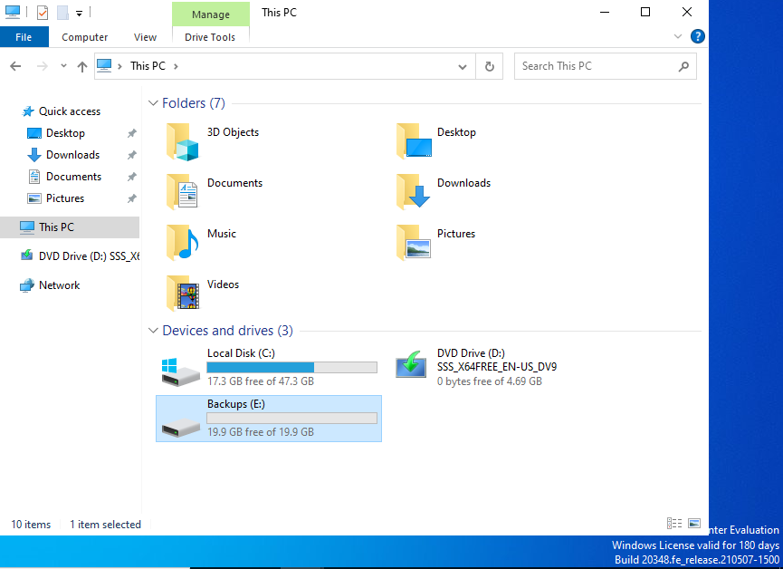

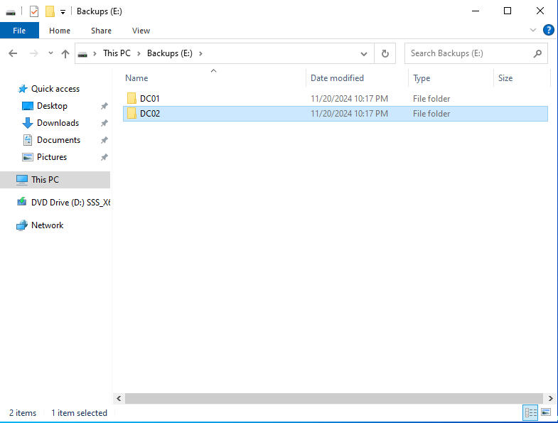

1. Share Backup Folders:

* Shared DC01 and DC02 folders as hidden shares (DC01$ and DC02$).
* Configured permissions to grant Backup Operators full control.

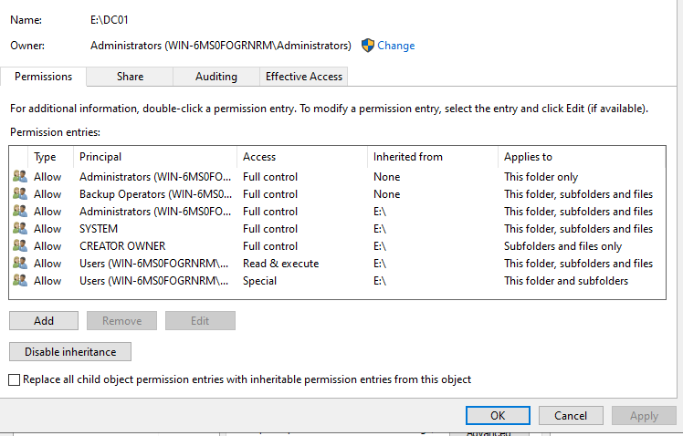

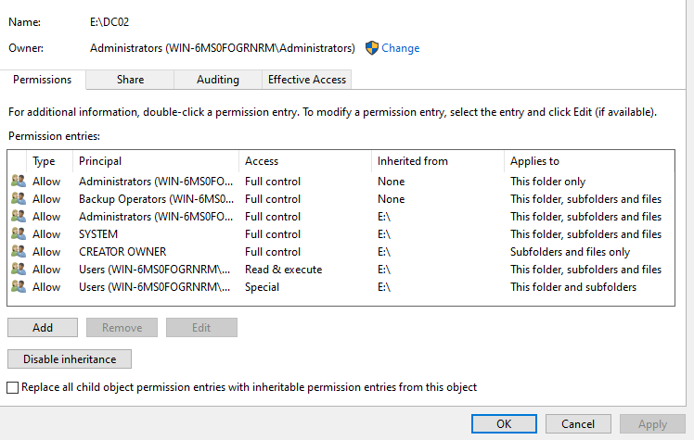

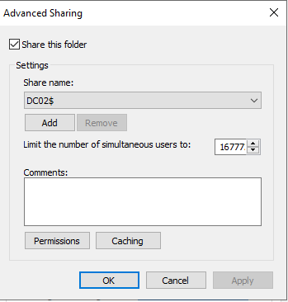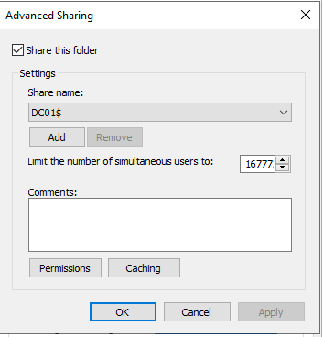

1. Install and Configure Windows Server Backup:

* Added the Windows Server Backup feature to RKDC01 and RKDC02.
* Configured scheduled backups to \\BackupSVR-01\DC01$ and \\BackupSVR-01\DC02$.

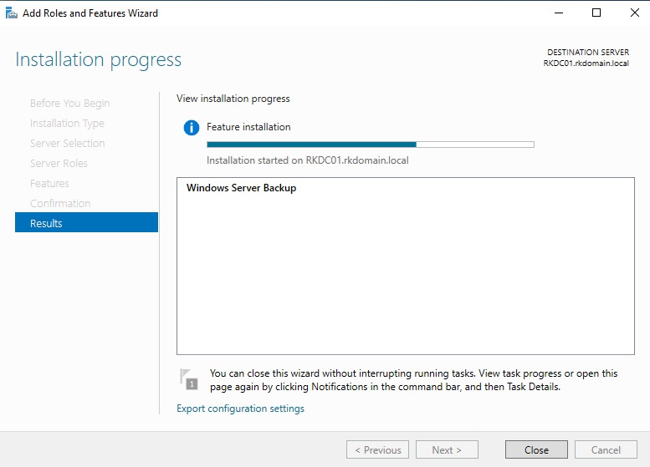

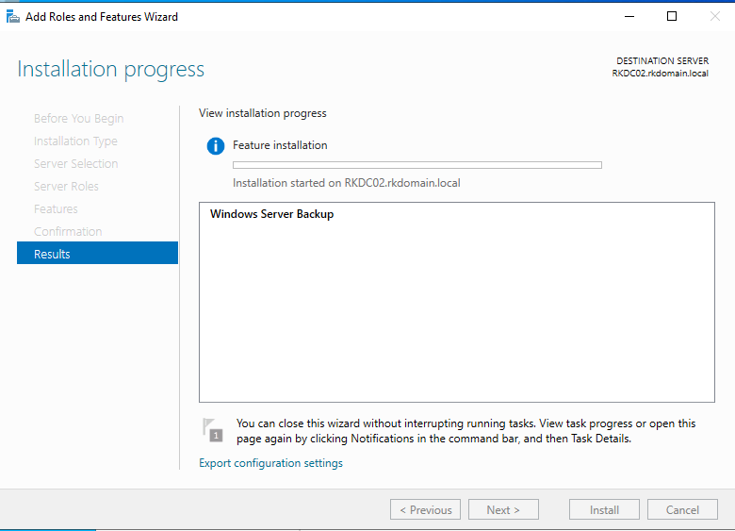

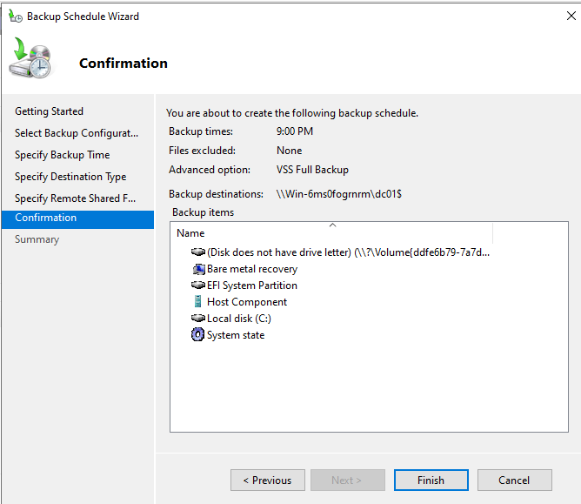

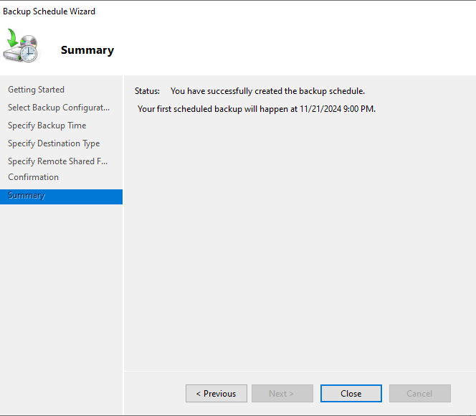

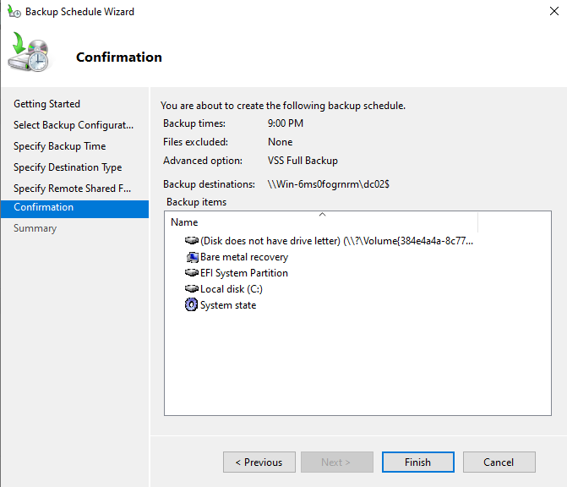

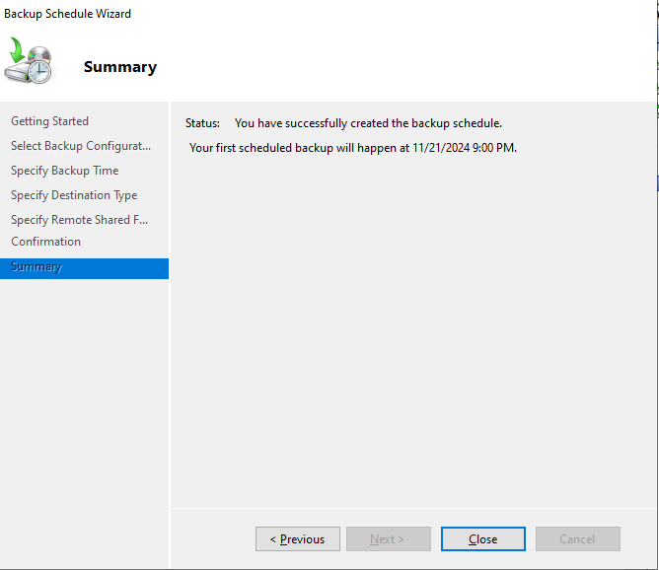

1. Perform Test Backup:

* Successfully initiated a one-time backup on both domain controllers.

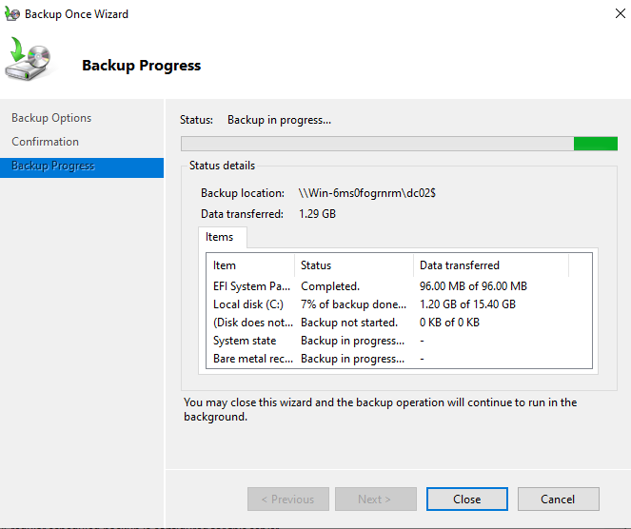

**Step 2: Design the OU Structure**

1. Opened Active Directory Users and Computers (ADUC) and created the following OUs:

* Sales, Marketing, Finance, IT, HR, Operations, R&D, Purchasing, Customer Service, Executive, Security Groups.

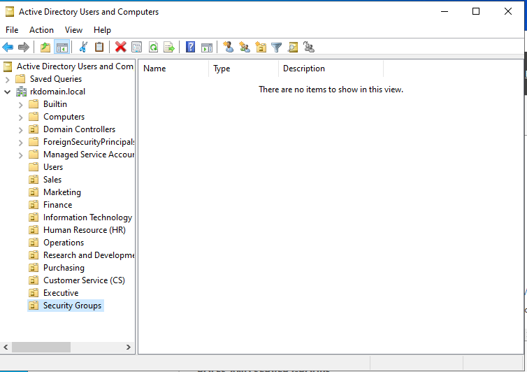

**Step 3: Create Security Groups**

1. Within each OU, created security groups for respective departments.
2. Configured groups as Security type and Global scope.

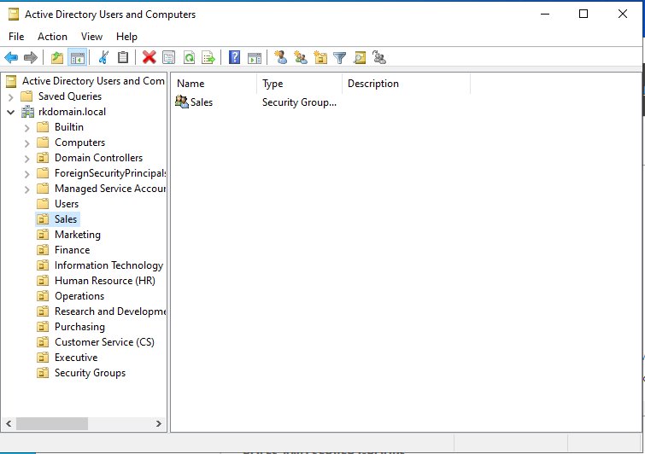

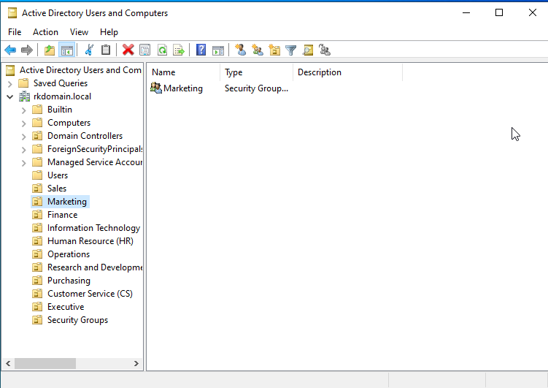

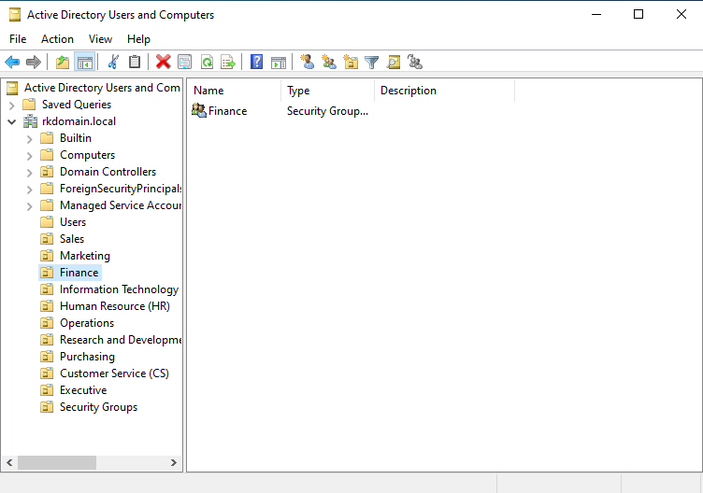

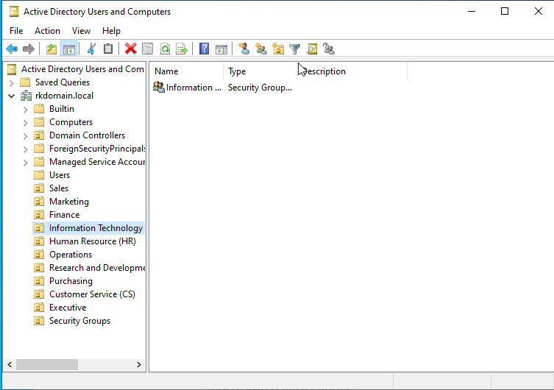

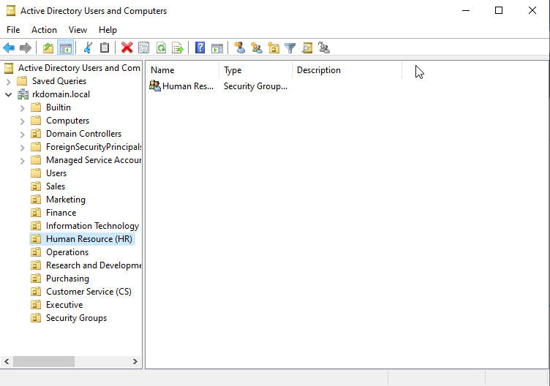

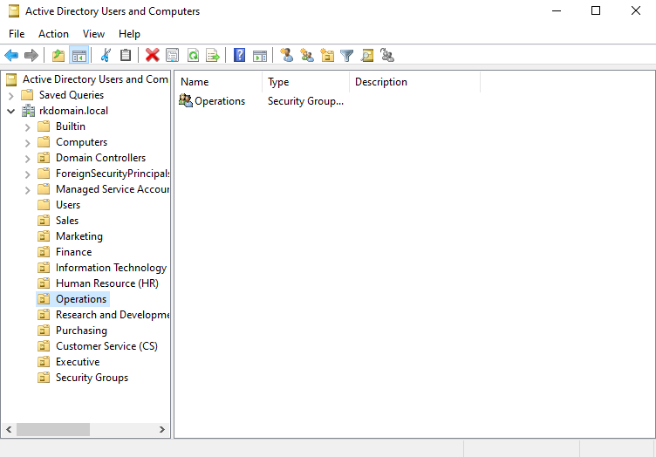

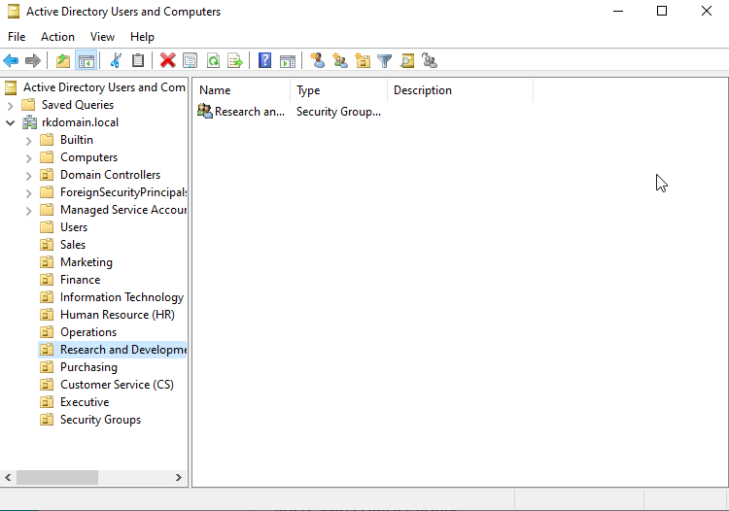

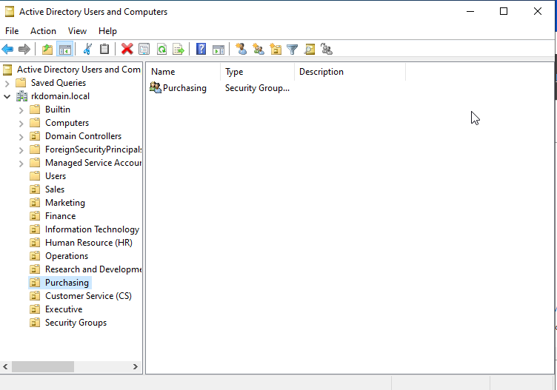

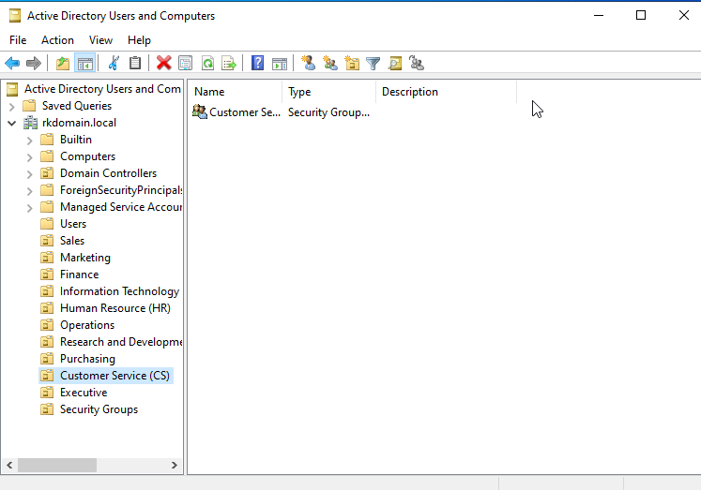

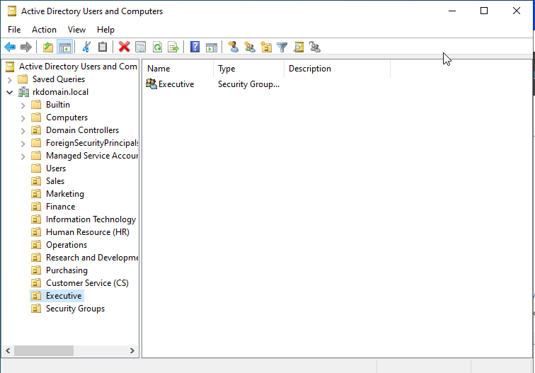

**Step 4: Create Users and Assign to Groups**

1. Created user accounts (e.g., SalesUser1, ITUser2) within respective OUs.
2. Assigned users to their departmental security groups via Member Of properties.

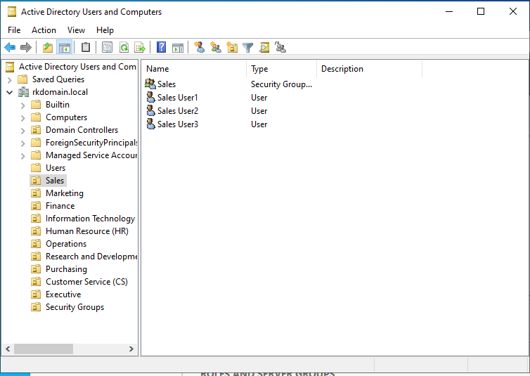

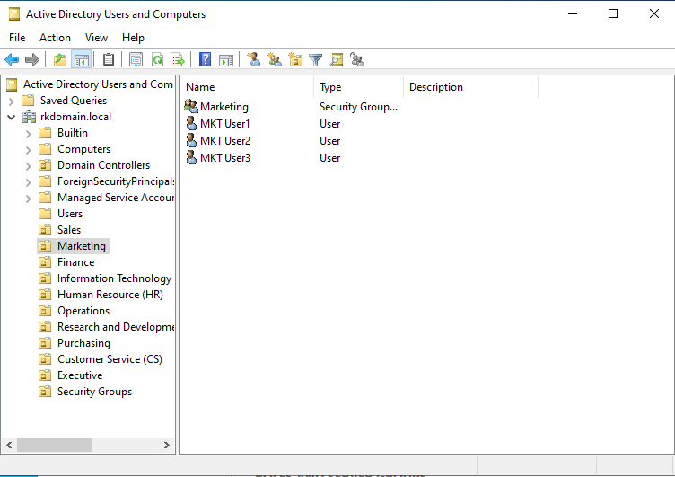

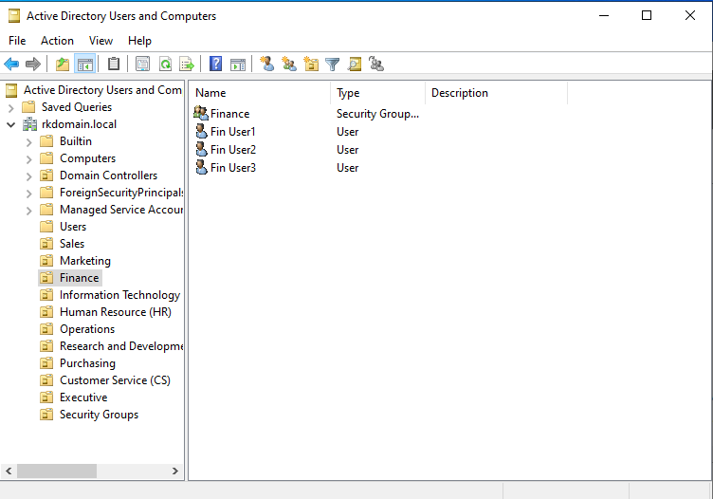

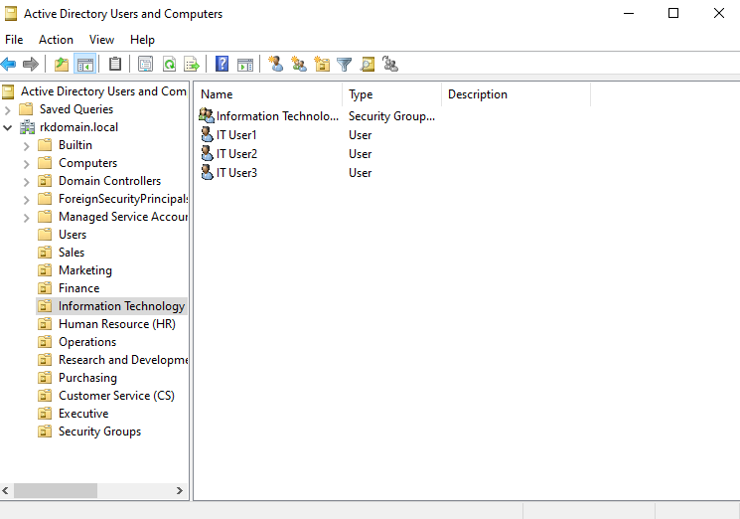

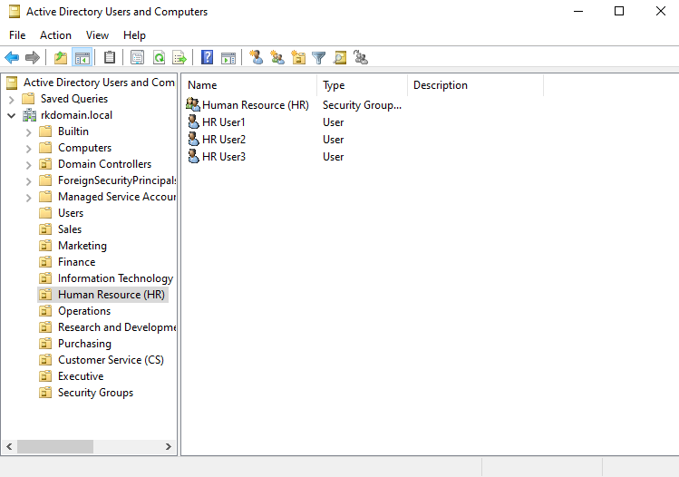

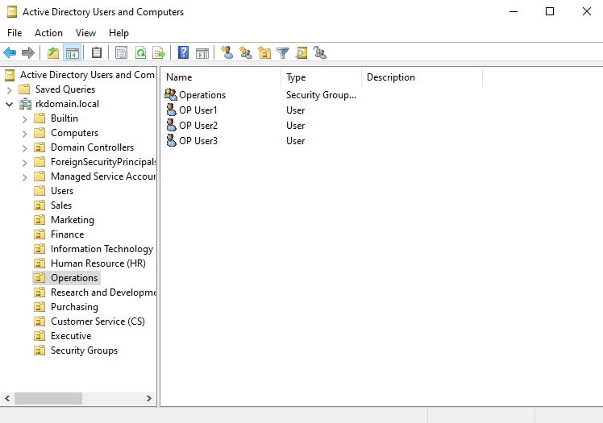

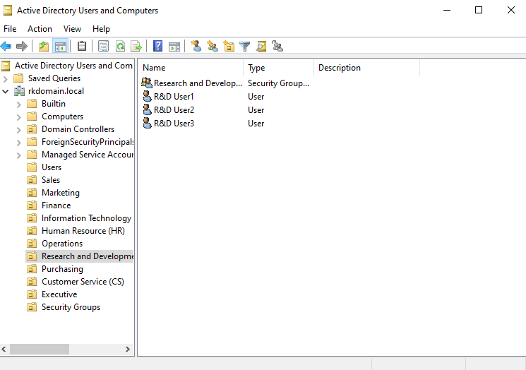

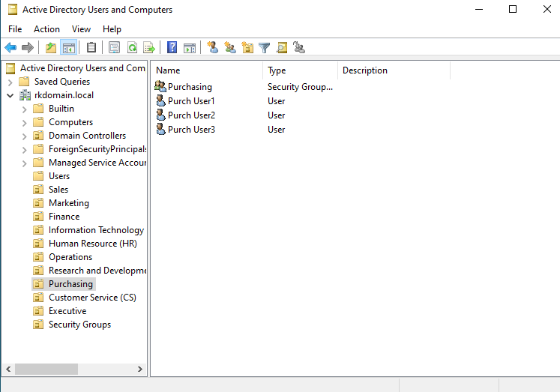

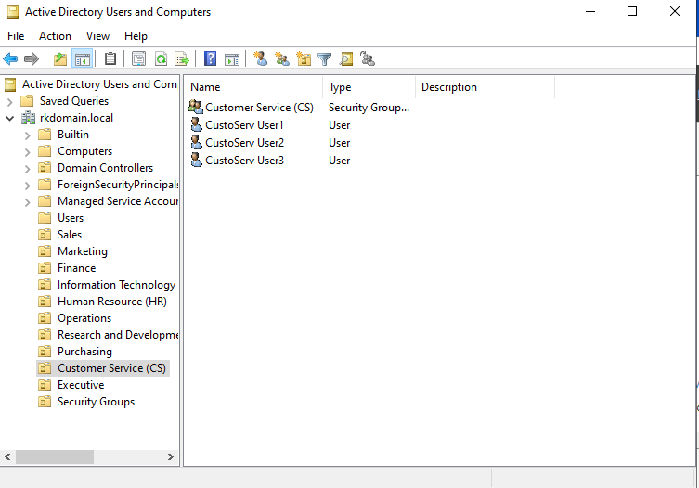

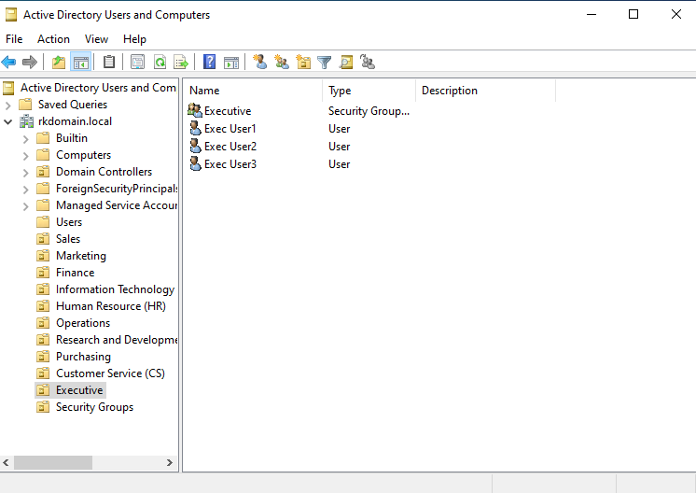

**Step 5: Test the AD Recycle Bin**

1. Deleted CustoServUser1 from the Customer Service OU.
2. Recovered the user using the Active Directory Recycle Bin via the AD Administrative Center.

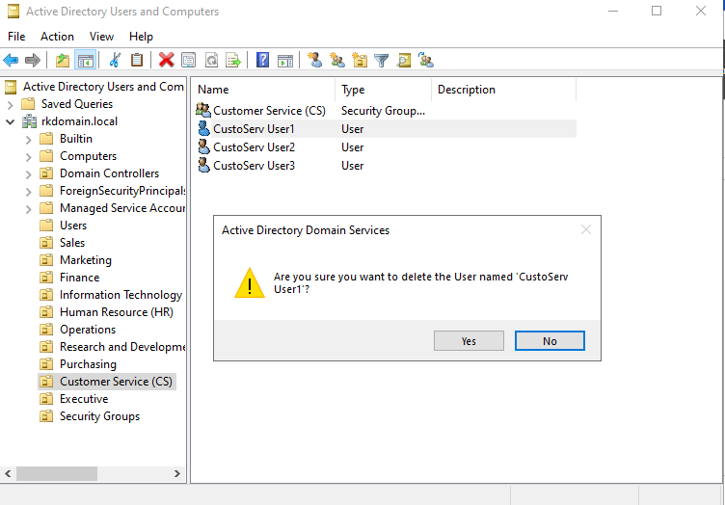

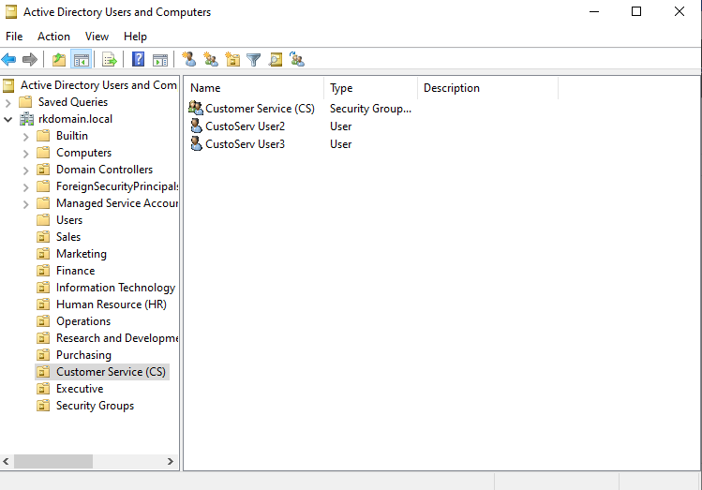

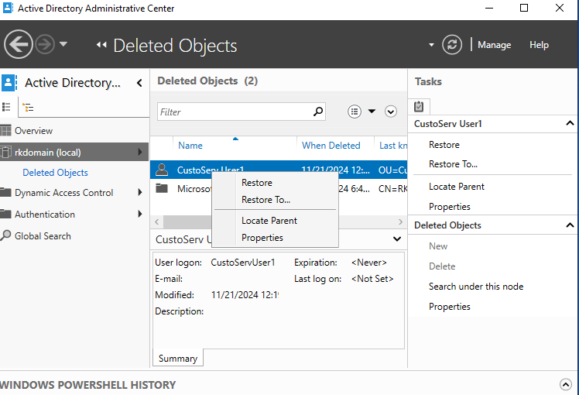

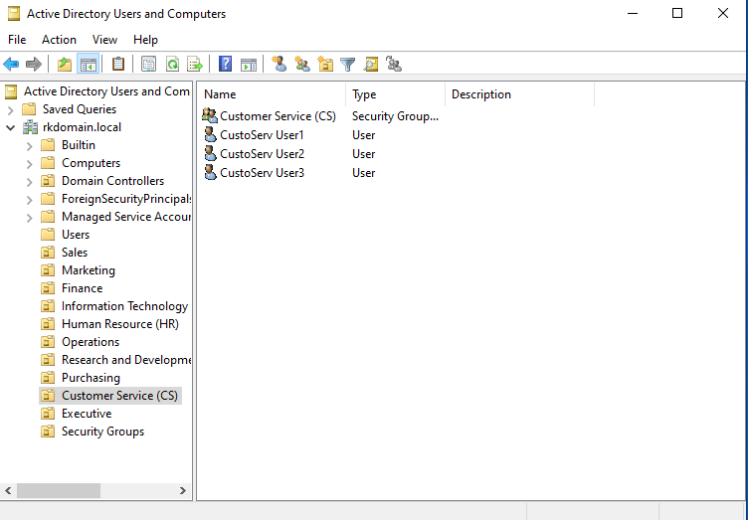

**Step 6: Manage FSMO Roles**

1. Transferred FSMO roles from RKDC01 to RKDC02:

* Used Active Directory Users and Computers and ntdsutil commands.

1. Transferred FSMO roles back to RKDC01.

**Testing and Verification**

1. Verified scheduled backups by reviewing the event logs for successful completion.
2. Confirmed the functionality of AD Recycle Bin through object restoration.
3. Tested FSMO role functionality by ensuring seamless operations post-transfer.

**Conclusion**

This project demonstrated the successful implementation of a disaster recovery plan, along with organizational design and management enhancements using Active Directory. The integration of Windows Server Backup ensures redundancy for domain controllers, while the designed OU structure facilitates better resource and user management. Testing FSMO roles and the AD Recycle Bin validated the system’s resilience and recoverability, providing a comprehensive learning experience in server administration.